Day43 - Task22 - Jenkins(Part-1)

1. Install Jenkins and run Jenkins on port number 8081.

Step 1: Install Jenkins

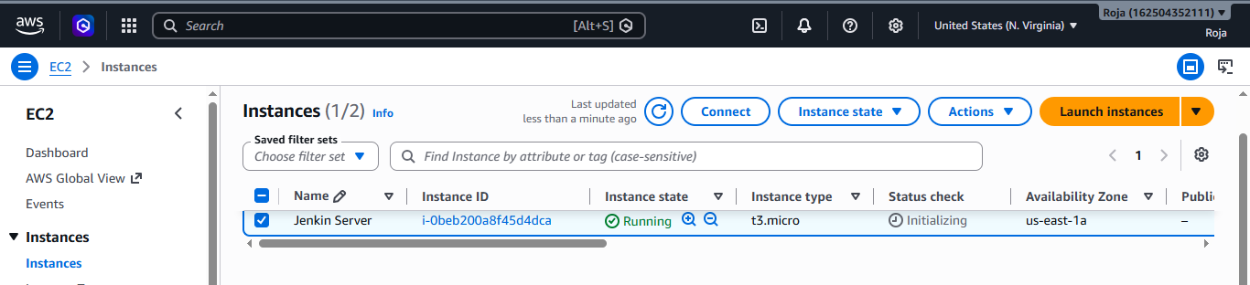

Step 2: Connect to the EC2 Instance
Connect to the Amazon EC2 instance using SSH or EC2 Instance Connect.
Verify the operating system:
cat /etc/os-release

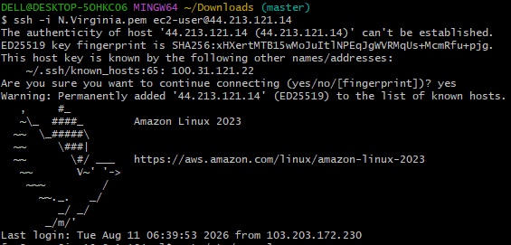

Step 3: Update the System Packages
sudo apt update
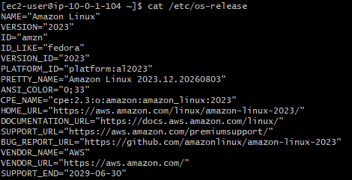

Step 4: Install Java

Jenkins requires Java to run. 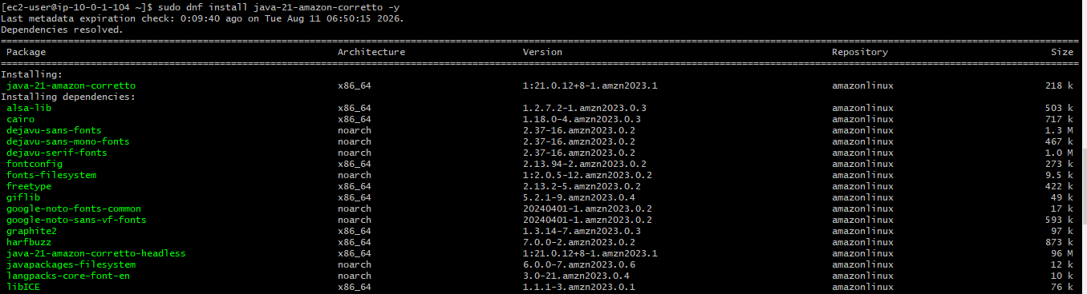
Installed Java and checked the java version
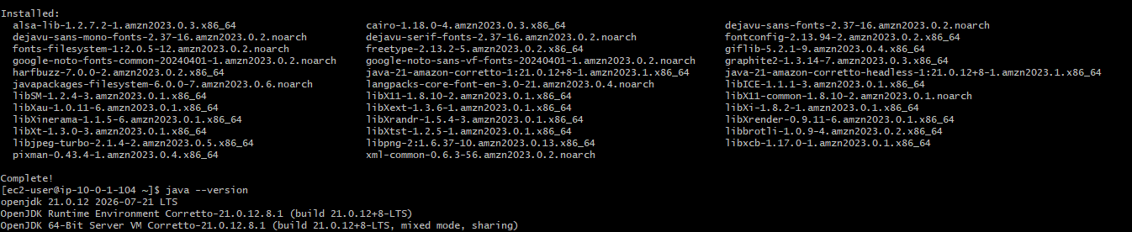
Step 5: Download the Jenkins repository key and Installed Jenkins
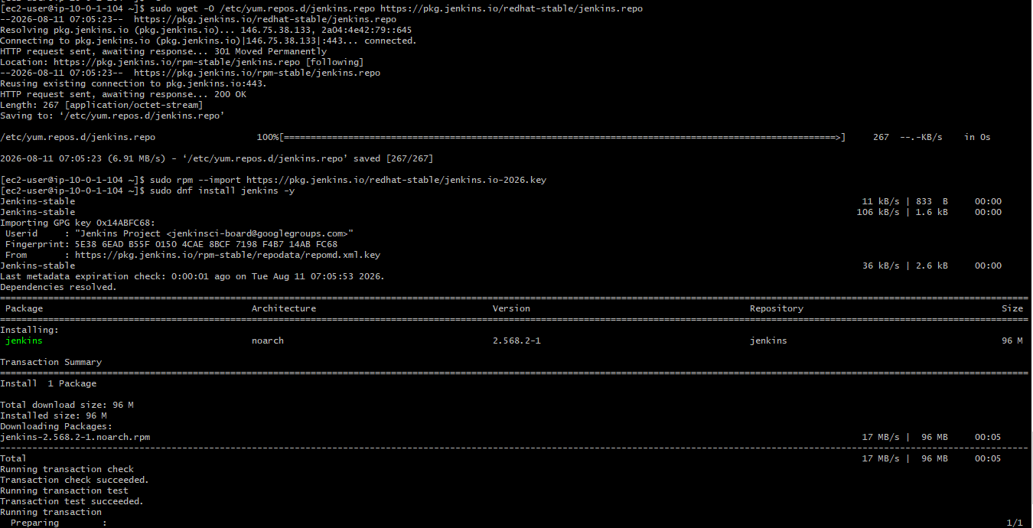
Checked the status of Jenkins and see that its inactive, so started Jenkins to see the status as active running.
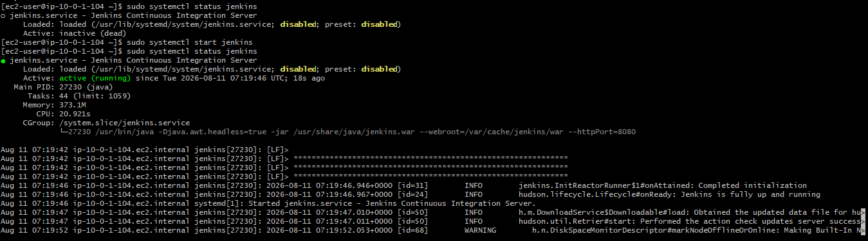

Step 6: Configure Jenkins to Run on Port 8081
By default, Jenkins runs on port 8080.
We need to change it to 8081.
Open the Jenkins configuration file: vi /usr/lib/systemd/system/jenkins.service
Find the port configuration.
If you see: HTTP_PORT=8080
change it to: HTTP_PORT=8081
Save the file:

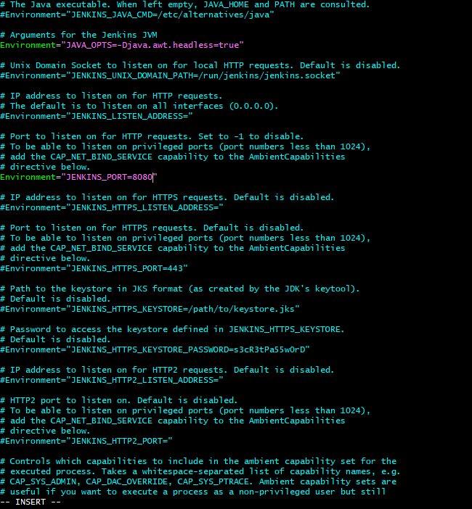
Use sudo systemctl daemon-reload to tell systemd to reload its service configuration files after you have modified a service configuration.
Enable and start Jenkins
Use sudo ss -lntp | grep 8081 to check if port is listening.
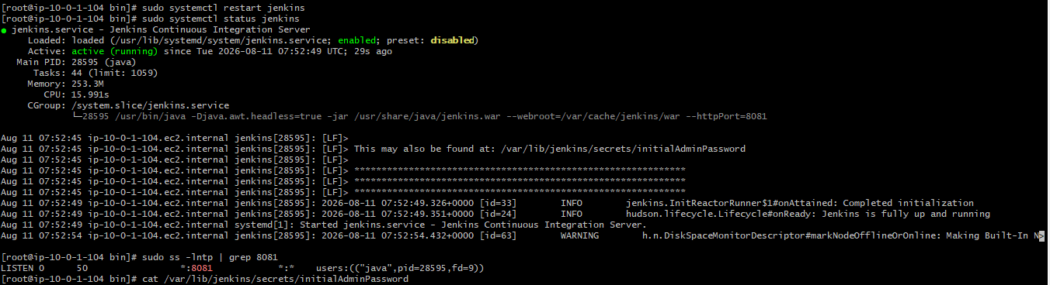
Now use http://Public IP:8081 to check the page on the browser.
Cat /var/lib/jenkins/secrets/initialAdminPassword to read the password and copy it to paste it in Jenkins console.
Then select first option and click on skip and continue to login as Admin.
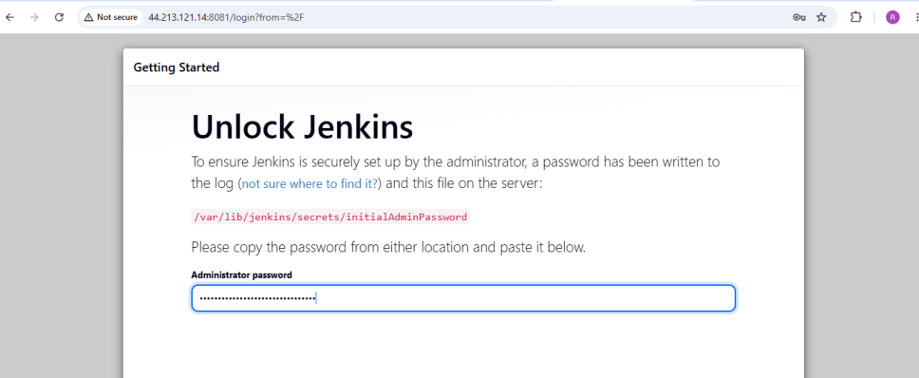

2. Secure Jenkins server

Step 1: Secure AWS Security Group
For Jenkins, allow port 8081 only from your IP address.
Type | Protocol | Port | Source
Custom TCP | TCP | 8081 | My IP
SSH | TCP | 22 | My IP

Avoid: 8081 → 0.0.0.0/0
For a production Jenkins server.
Instead use: 8081 → Your-Public-IP/32
This prevents the entire Internet from directly accessing Jenkins.
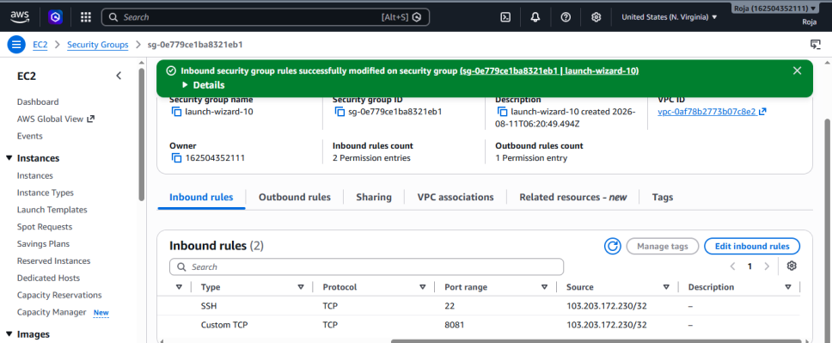
Step: 2 Change the password
Go to Jenkins Dashboard and click on profile and select Security.
Here change the password and delete the initial password in local server.
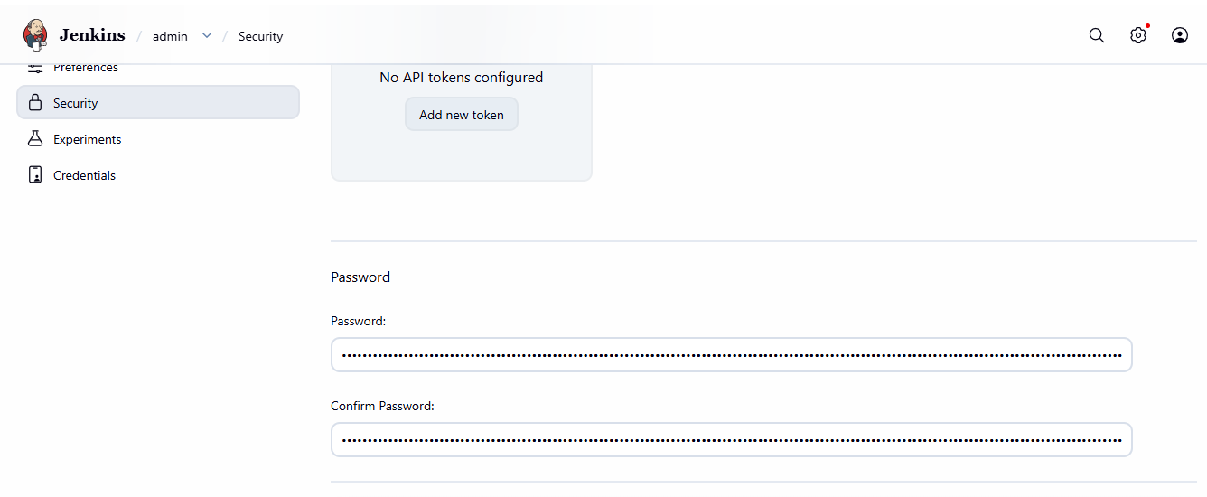
Now try to login with new password and below screenshot shows the successful login.
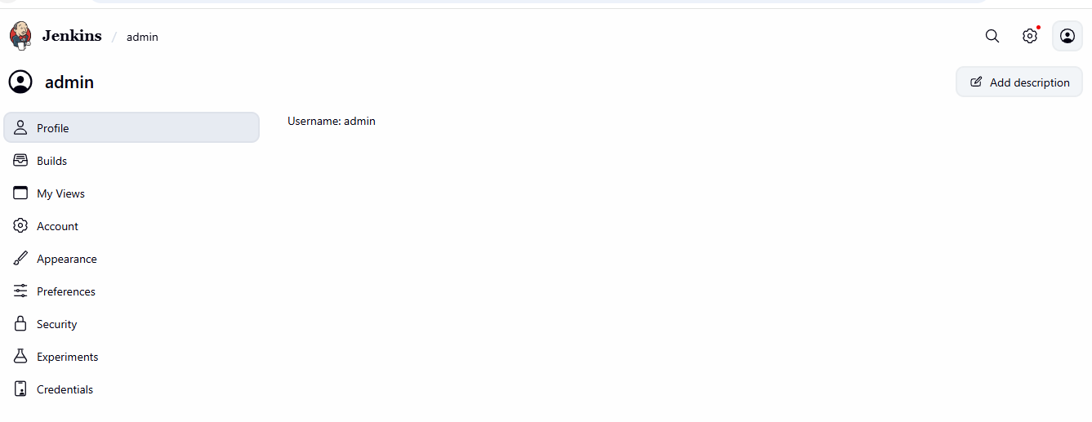
3. Create users called DevOps, Testing in Jenkins with Limited access.
Created 2 Users named Devops and Testing

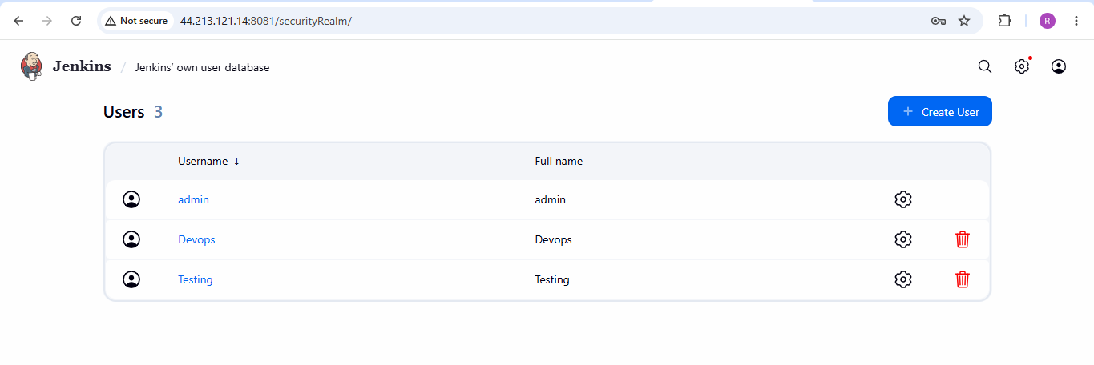

Limited access to the user Devops:
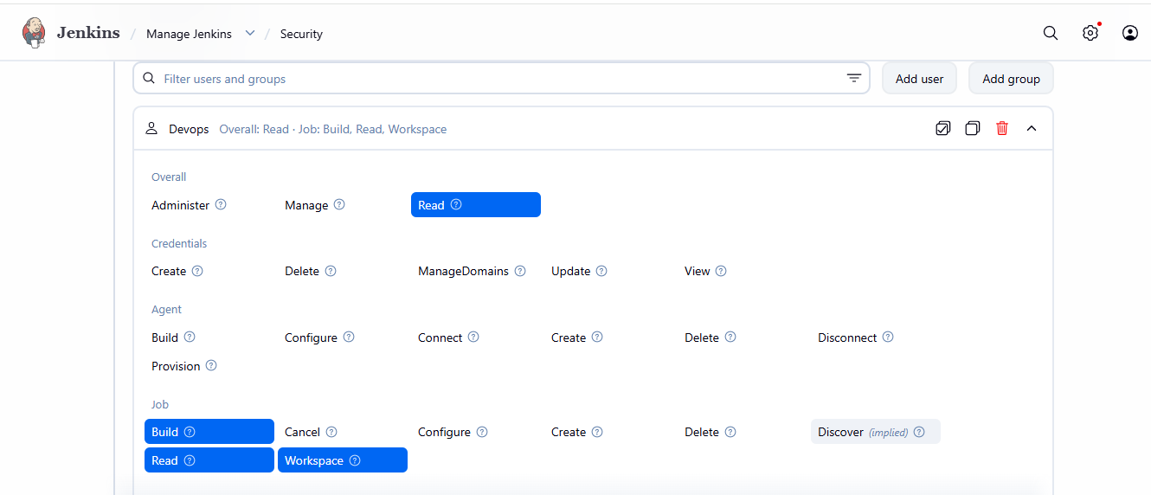

Limited access to the user Testing:
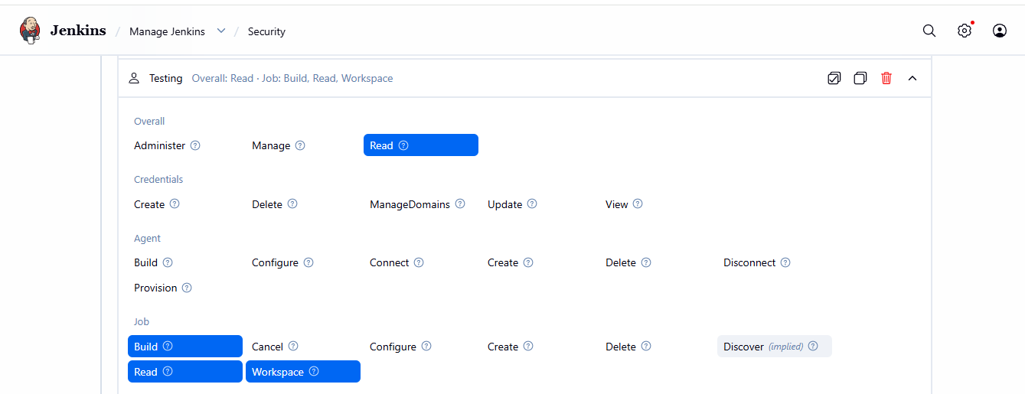

4. Configure labels and restrict the jobs to execute based on label only.
Created a job without configuring label and see that its waiting in queue to get executed.

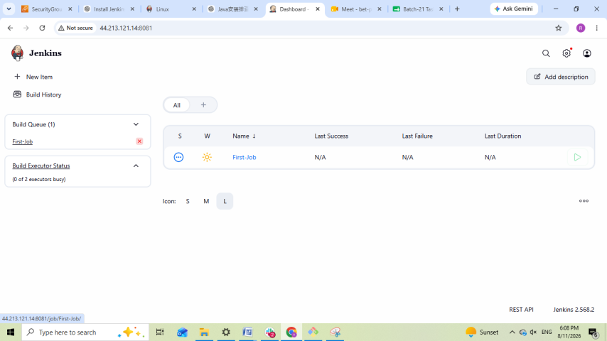
After creating a job by configuring label, it got executed without any error.
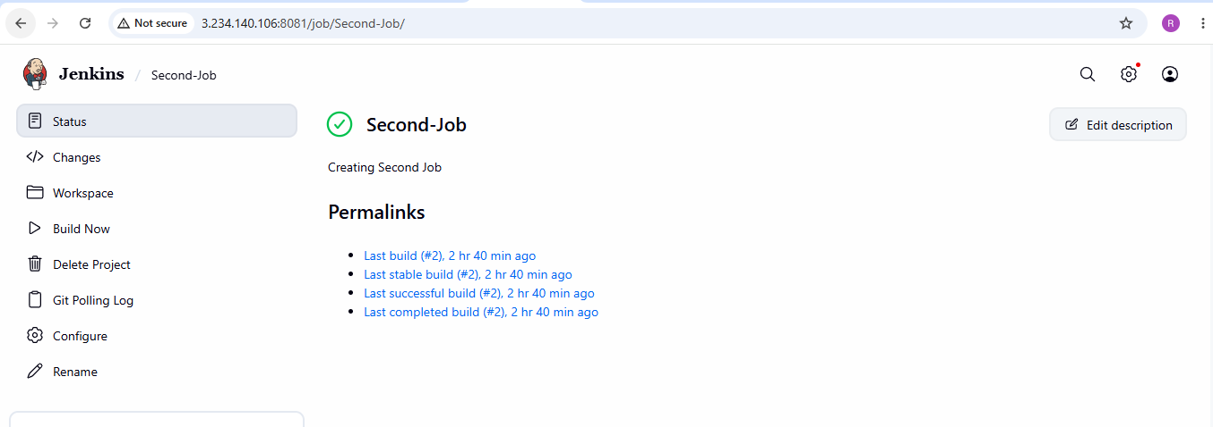
5. Create Three sample jobs using the below URL.
  - Source Code:https://github.com/betawins/Techie_horizon_Login_app.git

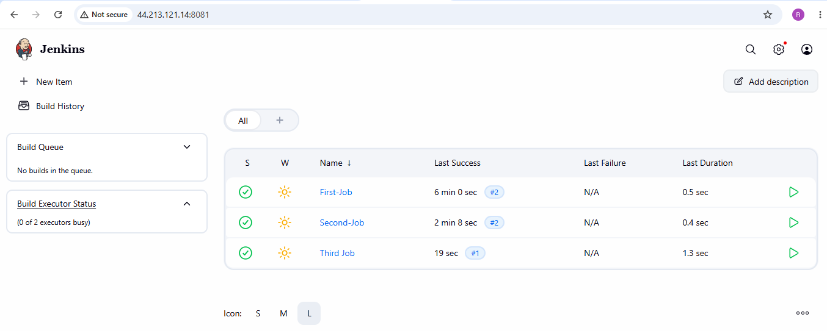

6. Create one Jenkins job using GitHub Private repository.
Created a private repo in remote machine and generated classic token.

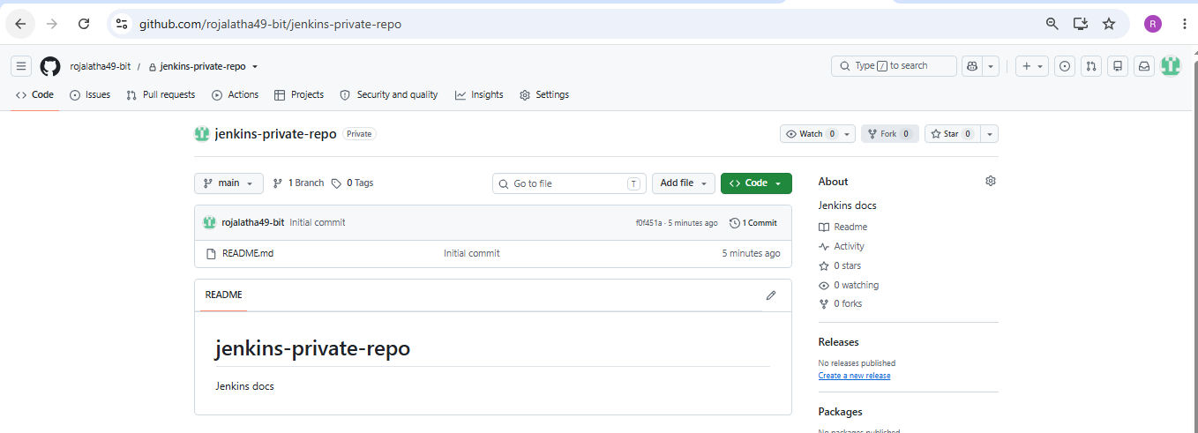
Created a job in Jenkins and configured credentials by entering user name and password.
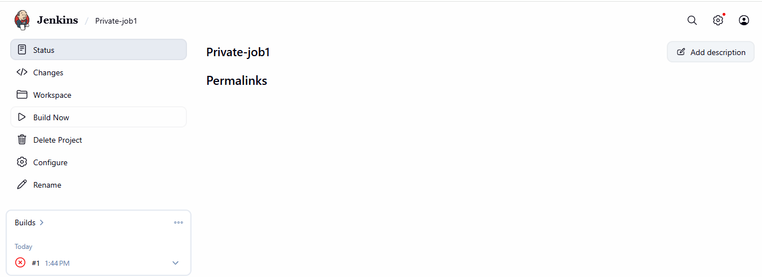
Now with the help of Repo url and credentials was able to execute the job Successfully.
